Title (Arial 12 pt bold) (the title must be the same as in the poster or paper submitted)
Authors’ names (Arial 11 pt): Name and Surname1¹ (please, underline the name and surname of the author attending the meeting), Name and Surname2², Name and Surname3³,
¹ Affiliation 1, Address 1, e-mail; ²Affiliation 2, address 2…
The abstract should be included below affiliations and addresses (in this part of the template) and should not exceed 1 page typed in Arial font, 10 pt.
All paragraphs should be justified. APA Rules Citation should be used for references (Arial font 8 pt., as shown in this example)
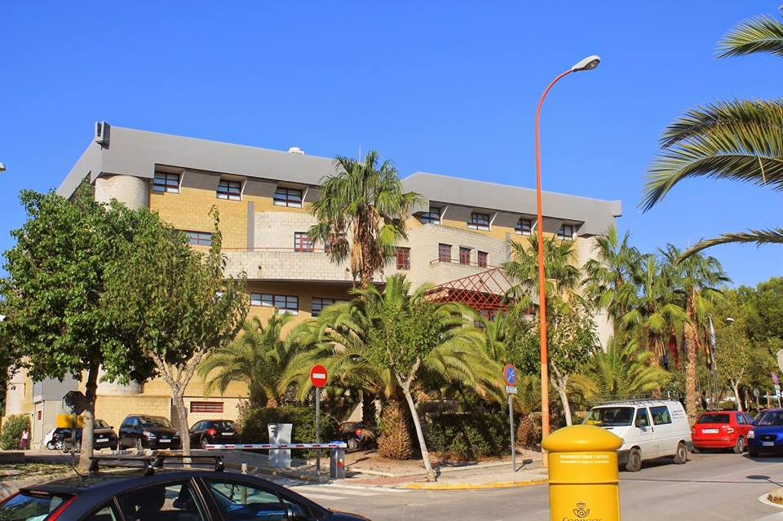
Figures (in black and white and jpg format or compatible with MSWord) should be inserted at the appropriate point in your text.
WORD files should be saved using the author’s surnames, the academic discipline (using the abbreviation code provided in table below) and the type of presentation (oral -CO- or poster -P-). Example: Sanchez_Gomez_FQ_CO.doc/docx. The word file should be uploaded to the website created for the 6th International Doctoral Conference.

Abstracts that do not conform with the above guidelines will NOT be accepted.

Academic discipline | Code | Academic discipline | Code
Arts and Humanities | AH | Physics, Chemistry and Chemical Engineering | FQ
Biology, Biochemistry and Biotechnology | BI | Geography and History | GH
Business Sciences | CE | Information and Communication Management | GI
Forensic Sciences | CF | Computer Sciences, Engineering, Architecture and Technology | IA
Political Sciences | CP | Mathematics | MA
Criminology | CR | Medicine, Nursing, Physiotherapy, Psychology, Health, Aging | SA
Law, Biolaw | DE | Physical Activity and Sport | AF
Economics | EC | Industrial Relations, Sociology and Social Work | RS
Education and Educational Technology | ED | Food Technology, Nutrition and Bromatology | TA
Philosophy | FI | Veterinary | VE

References
Author1,
Author2,
Author3,... (APA rules citation)

