
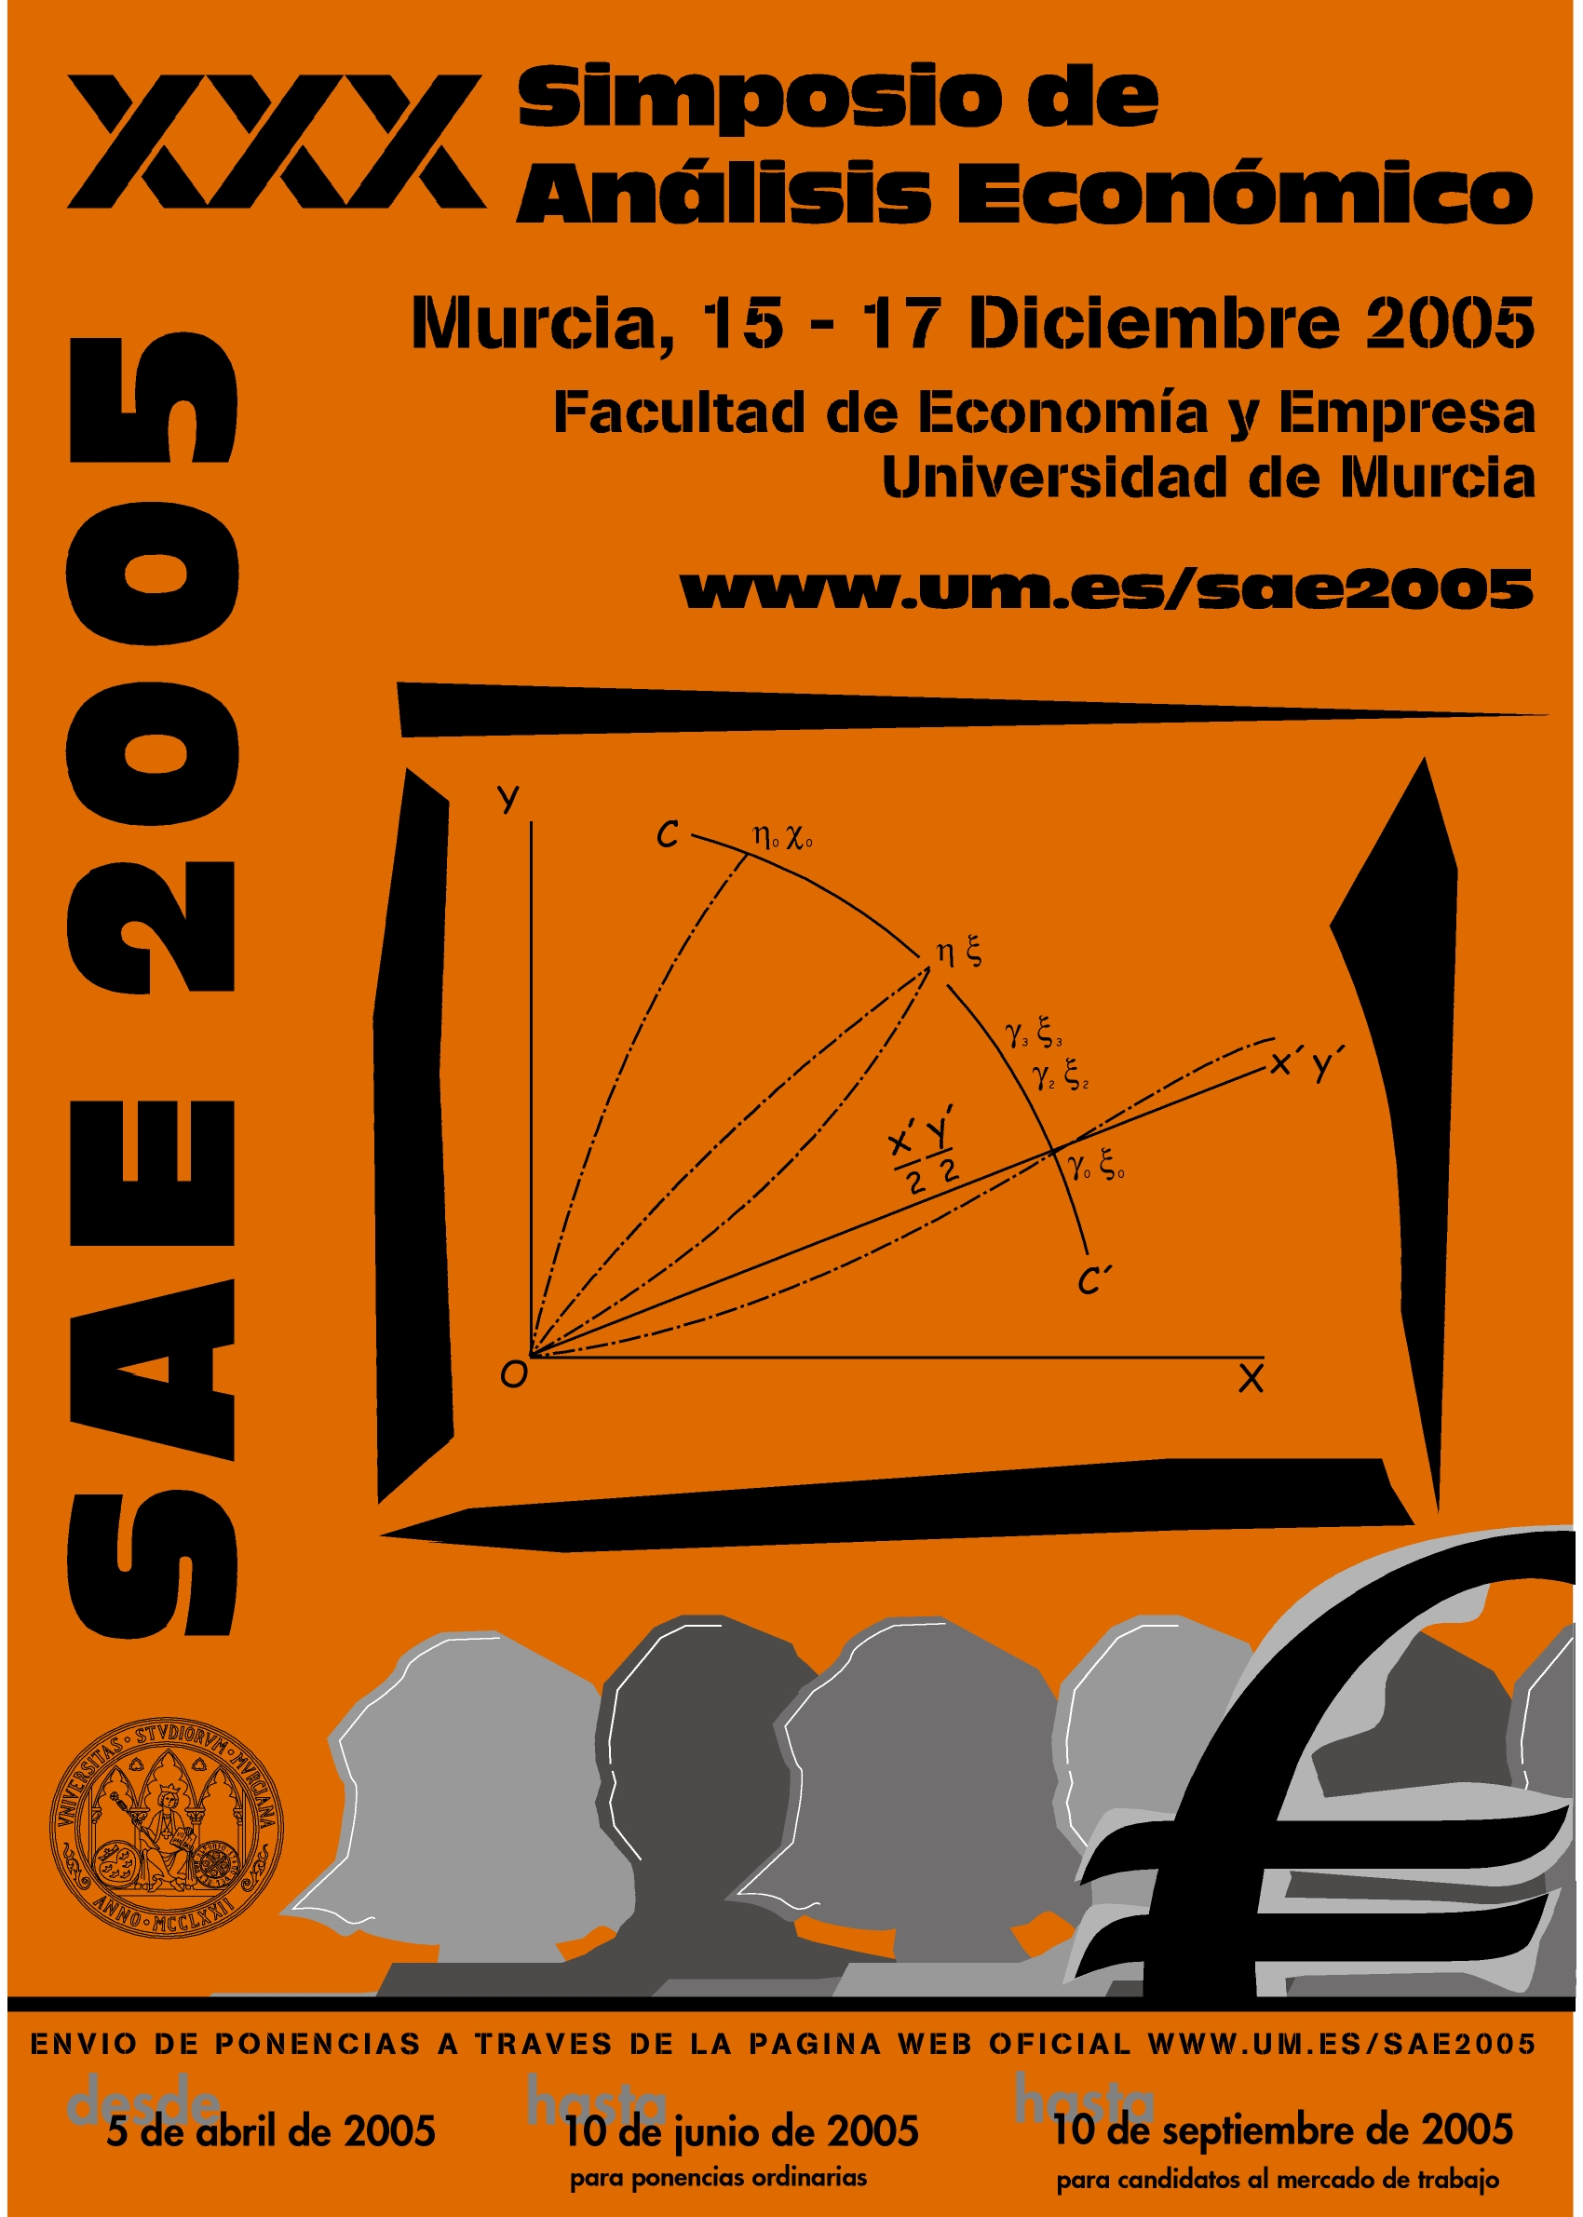

XXX SIMPOSIO DE ANÁLISIS ECONÓMICO

Murcia, December 15th -17th, 2005
www.um.es/sae2005
REGISTRATION FORM

PARTICIPANT

IDENT NUMBER (*) (Mandatory. Participants that do not provide this number will not be included in the scientific program)

(*) If you have already created a personal profile (when submitting your paper) you will have been given a personal ident number. You can obtain your ident number at http://www.webmeets.com/sae/2005/AboutYou/ where you will need to login using your profile. You may also find your IDENT number in your paper submission receipt which was sent to you via email upon completion of your submission.

Name
Family Name
Passport Nr.
Address

Postal Code

City
Country
Telephone Nr.
Fax Nr.
E-mail
Institution

REGISTRATION FEES Before November, 11th After November, 11th

- Regular participant  - Job Market participant | 150,00 € 300,00 €  105,00 € 210,00 €
* If you are going to present a paper, your registration must be received before November 25th. Otherwise your paper will not be included in the final program.
OTHER QUESTIONS

- I will attend the Wellcome Cocktail (15th Thursday) Yes No
- I will attend the Symposium Dinner (16th Friday) Yes No
- I will attend the Symposium Lunches on 15 th Yes No; 16 ^{th} Yes No; 17 th Yes No

* All these meals are included in the registration fee.
PAYMENT

Cancellation:Before November 11th: 100 % refund. Between November 11th and November 30th :75 % refund. After November 30th: no refund. Cancellations must be sent in written to the Conference Secretariat. Reimbursements will be made once the conference has finished.

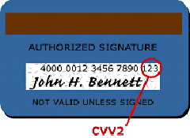
In case of Bank transfer, please send us receipt by fax. Registrations will only be confirmed once the payment has been checked.

Bank transfer free from cost to: Viajes CajaMurcia Saving Bank: Cajamurcia
Account number ES 09 2043 0133 75 020 0003744 Swift Code: CECAESMM 043
Please remember to indicate on the heading of the bank transfer : ”SAE/ Family name, Name”

Credit Card – I authorise to charge my credit card with the total amount indicated. We accept:

VISA AMERICAN EXPRESS MASTER CARD DINERS CLUB

Card Holder Card Number Expiring date (mm/yy) CVV2 Number
Total amount € Signature
HOW TO SEND THIS FORM
Save as ….. “REG SAE - FAMILY NAME, NAME” and send it as attached document before November 11th, 2005 to : congresos@viajescajamurcia.com
Please indicate on the e-mail subject: “REG SAE – FAMILY NAME, NAME”

Or print it and send it by fax before November 11th, 2005 to:

Technical Secretariat: VIAJES CAJAMURCIA – Conference Department
Gran Vía Esc. Salzillo, 5, Entlo. Dcha. • C.P. 30004 • Murcia •
Tel. Nr.: 00 34 968 22 54 76 • Fax Nr: 00 34 968 22 31 01 • congresos@viajescajamurcia.com

